Tox-Scraper MCP — System Design Blueprint
Two deployment cases · Shared deterministic core · April 2026

1. Purpose
This blueprint shows two supported ways to run the Tox-Scraper MCP server. The server itself is identical in both cases — same Python code, same 4 tools, same evidence ledger, same deterministic report. What changes is who stands in front of it: a conversational LLM (Claude) or a headless web backend (Node.js). Use this to pick the right front door before we build anything further.
2. The Shared Core (unchanged in both cases)
Before the two diagrams diverge, note what stays the same. The Python MCP server exposes four tools — resolve_chemical, harvest_evidence, build_review, audit_run — that together consume external toxicology APIs, write a JSONL evidence ledger and a JSONL trace log to disk, and emit a 29-section Word document. The pipeline is LLM-free, deterministic, and replayable by run_id. Both cases below call this exact same server over stdio using the MCP JSON-RPC protocol.
- 4 MCP tools — resolve_chemical, harvest_evidence, build_review, audit_run
- 14 active database harvesters · 29 review sections · 570 routing keywords
- Disk artifacts per run: evidence.jsonl, trace.jsonl, <chemical>.docx
- Zero-hallucination guarantee: audit enforces every paragraph traces to ledger

3. Case 1 — Claude as Host (conversational UI)
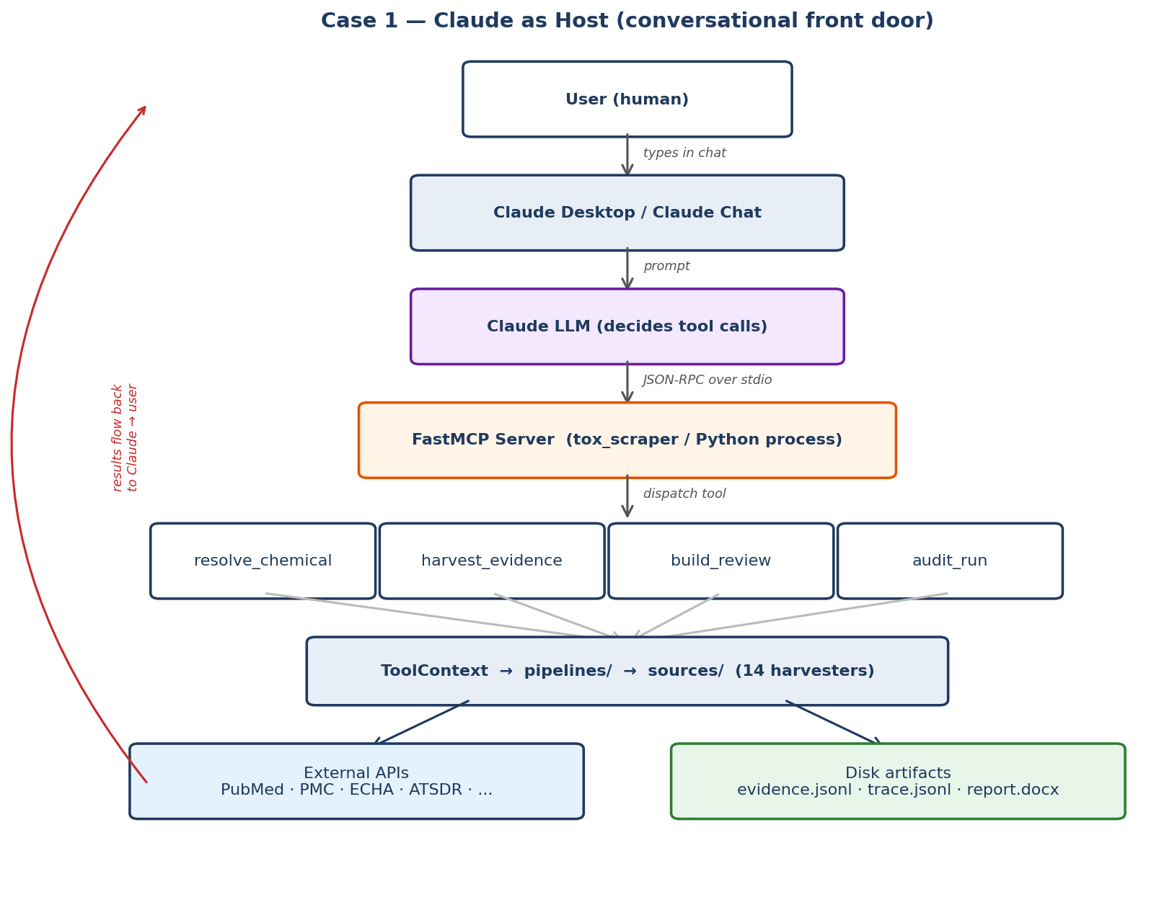
How a request flows
The user types a natural-language request in Claude Desktop or Claude chat. Claude's model reads the prompt, sees the four tox-scraper tools in its tool list, and decides which one to call first. It emits a JSON-RPC tool call over stdio to the FastMCP server, which dispatches the call to the matching Python function. That function runs pipelines and sources, hits external APIs, writes to the ledger and tracer, and returns a result. Claude reads the result, decides whether to call the next tool, and eventually replies to the user in natural language with a link to the generated report.
Strengths
- Natural-language interface — no form, no schema to learn
- Adaptive orchestration — Claude retries with synonyms, handles errors in dialogue
- Follow-up Q&A over the generated report ("summarise inhalation findings")
- Zero front-end build cost — Claude Desktop is already the UI
Trade-offs
- LLM token cost per session · non-zero latency from the model's own reasoning
- Different runs of the same prompt can pick slightly different tool-call paths
- Requires the user to have a Claude client installed and authenticated
Best for
Interactive analyst workflows — a scientist exploring one chemical at a time, asking follow-ups, comparing sections, probing the ledger conversationally.

4. Case 2 — Node.js Backend as Host (no LLM)
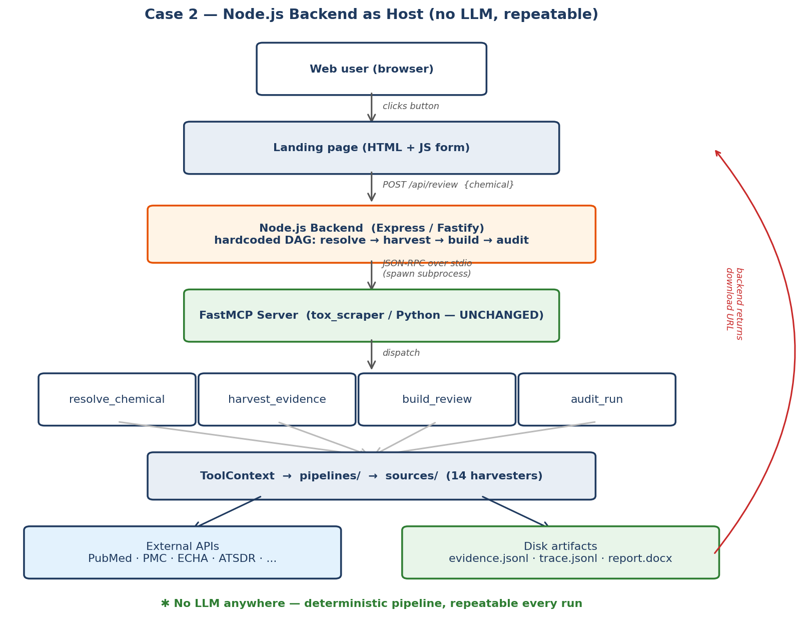
How a request flows
A user visits a landing page and submits a chemical name via a simple form. The page POSTs to a Node.js backend endpoint (for example POST /api/review). The backend spawns the tox-scraper MCP server as a child process over stdio and calls the four tools in a hardcoded DAG: resolve → harvest → build → audit. No LLM is involved in tool selection — the sequence is fixed in code. When the audit returns, the backend responds to the browser with a signed URL to the generated .docx plus a pass/warn/fail badge from the audit verdict.
Strengths
- Fully deterministic — same input always produces the same tool-call path
- No LLM API cost · no token latency · lower total wall-clock time
- Trivial to batch — loop over a CSV of chemicals, one docx per row
- Friendlier to non-technical users — a button, not a chat window
- Easy to audit for compliance (exact call sequence is version-controlled)
Trade-offs
- No conversational Q&A over results — just the generated report
- No adaptive retry logic — errors surface raw unless the backend handles them
- Requires building and hosting the Node.js service + landing page
Best for
Production workflows — a nightly batch of 500 chemicals, a regulatory team running standard reviews, or any setting where repeatability and cost control matter more than conversational flexibility.

5. Side-by-Side Comparison
Dimension | Case 1 — Claude Host | Case 2 — Node.js Host
Front door | Claude Desktop / Chat | Web landing page
Orchestrator | Claude LLM (adaptive) | Node.js backend (fixed DAG)
Tool-call path | Variable per run | Identical every run
LLM cost per request | Yes (tokens in + out) | None
Wall-clock latency | Model latency + pipeline | Pipeline only
Determinism | High for data, soft for flow | Fully deterministic
Follow-up Q&A | Yes — natural dialogue | No — one-shot report
Batch / CSV jobs | Awkward | Trivial
Auth model | Claude account | Your SSO / API key
Infra to host | Claude Desktop only | Node service + static site
Scientific output | Identical .docx + ledger | Identical .docx + ledger
Audit guarantee | audit_run enforced | audit_run enforced
6. Recommendation
Build Case 1 first (it already works today) for internal exploration and quick demos. Once the shape of a canonical review is locked in, wrap the same server with the Case 2 Node.js backend for production rollout. Because both cases call the identical Python server, there is no code duplication and no risk of scientific drift between the two surfaces. The MCP protocol is the decoupling layer that makes this possible — swap the host, keep the science.
7. Appendix — Minimal Node.js Backend Skeleton
For reference, a production Case 2 backend is ~60 lines of Node.js. It spawns the Python MCP server once at startup, holds the stdio pipe, and exposes a single POST endpoint that runs the four-tool DAG and returns a download URL.
// server.js (Express + @modelcontextprotocol/sdk)
import express from 'express';
import { spawn } from 'node:child_process';
import { Client } from '@modelcontextprotocol/sdk/client/index.js';
import { StdioClientTransport } from '@modelcontextprotocol/sdk/client/stdio.js';
const app = express(); app.use(express.json());
const child = spawn('python', ['-m', 'tox_scraper.server']);
const client = new Client({ name: 'tox-landing', version: '1.0' });
await client.connect(new StdioClientTransport(child));
app.post('/api/review', async (req, res) => {
const { chemical } = req.body;
const id = await client.callTool('resolve_chemical', { name: chemical });
const run = await client.callTool('harvest_evidence', { cas: id.cas });
const doc = await client.callTool('build_review', { run_id: run.run_id });
const aud = await client.callTool('audit_run', { run_id: run.run_id });
res.json({ report_url: doc.path, status: aud.status });
});
app.listen(8080);

